

*Assignment Cover Sheet:* Please attach this cover sheet to the front of **every assignment** you submit to the university. Please be sure to **sign the declarations below** before you submit this sheet. Failure to sign the declarations may result in your work being unmarked.

|  |  |
| --- | --- |
| **Student Name** | Edlira Taipi |
| **Student ID** | 24025443 |
| **Programme** | MSc Digital Marketing |
| **Module Name & Code** | DGM24705-Global Marketing and Sustainable Practises |
| **Assignment Name & No.** |  |

**Declaration:**

I have complied with [Ravensbourne University’s Academic Regulations](https://www.ravensbourne.ac.uk/asset-bucket/prod/2023-08/Ravensbourne%20University%20General%20Academic%20Regulations%202023-24.pdf) and have **acknowledged** the work and ideas of others that I have used in the production of this assignment.

Signed: _________Edlira Taipi___________________

I have read the MSc Digital Marketing course statement on AI and can confirm that **I have not used** AI/LLM technologies in the production of this assignment:

Signed: ____________________________

I have read the MSc Digital Marketing course statement on AI and can confirm that **I have used** AI/LLM technologies in the production of this assignment:

Signed: _________Edlira Taipi___________________

|  |  |
| --- | --- |
| **Software used and publisher:**  i.e., ChatGPT4/Canva Magic Studio  Grammarly |  |
| **Links** |  |
| **Description and rationale of the use of AI software:** add evidence where appropriate. | I have used AI as a research tool not as a asset. |

Date:____________19/06/2025________________

Student Name: Edlira Taipi

Student Number: F2411085

**Student ID:24025443**

Module Code: **DGM24705**

**GLOBAL MARKETING AND SUSTAINABLE PRACTICES**

**TABLE OF CONTENTS**

Task 1: Marketing Plan Report 4

Introduction 4

Advertising and Marketing Communication Objectives 5

Target Audience 5

Positioning Strategy 6

Digital Marketing Communication Strategy 7

Campaign Timeline 8

Campaign Monitoring and Evaluation 9

Recommendations 10

Conclusion 11

References 12

Appendix 13

# Task 1: Marketing Plan Report

## Introduction

The focus of ***Sustainable Development Goal (SDG) 13 (Climate Action)*** is to inevitable action to begin tackling climate change and its impact (UNDP, 2025). With the intensification of climate change globally, Greece becomes more and more vulnerable to rising temperatures, fires, sea-level rise and extreme weather in the Mediterranean region. In Greece, the temperature has increased by 1.5°C since the 1855s to 2023, and in the Hellenic National Meteorological Service data from the last two decades, the average summer temperature has risen by 2°C (Matzarakis and Nastos, 2024). Moreover, the season of the wildfire has become longer and more damaging to biodiversity and tourism.

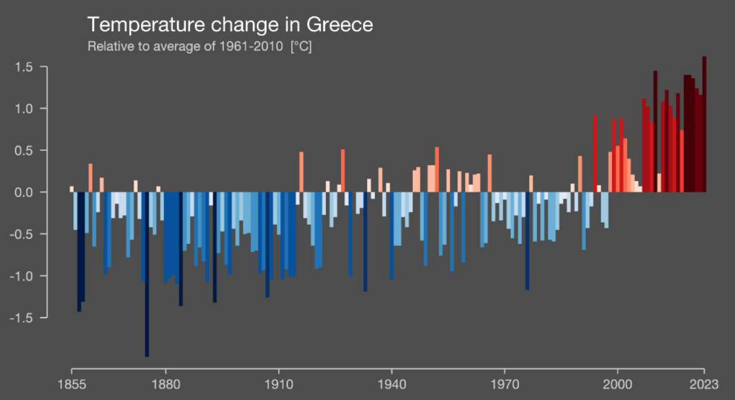

**Figure 1: Temperature change in Greece**

(Source: Matzarakis and Nastos, 2024)

The aim of this marketing plan is to generate awareness and encourage the young Greek citizens (18-30 years old) to engage in eco-friendly behaviour by empowering SDG 13. This is not solely informative but also aims to inspire a role of active role in the climate change mitigation process through changing one’s lifestyle, advocacy, and support for local environmental initiatives.

## Advertising and Marketing Communication Objectives

The objective of communication of the campaign is as follows:

* ***Increase Awareness:*** Achieve a 40% increase in SDG 13 by the end of 6 months from the target audience through online surveys.
* ***Promote Behavioural Change:*** Campaign followers are motivated to perform one or more climate-positive behaviours (such as using public transport, reducing meat consumption, recycling) and promote behavioural change amongst others by 25%.
* ***Increase Participation:*** Generate a 30% increase in Tampon involvement in local climate movement events and virtual initiatives like writing sustainability messages and signing climate petitions (Richardson, 2020).
* ***Brand Recognition:*** Other than 'Act Now Greece', it should also be noted that 85% of participants should remember the campaign when presented with it in two months after the campaign's end.

## Target Audience

***Demographic Characteristics:***

* ***Age:*** 18–30 years
* ***Gender:*** All genders
* ***Location:*** Urban areas (Athens, Thessaloniki, Patras)
* ***Education:*** High school diploma and above
* ***Income:*** Low to medium (students, young professionals)

***Psychographic Characteristics:***

* Environmentally concerned or curious
* Progressive and digitally active
* Attitude towards value sustainability, social equity and ethical consumption
* An activist, a fashion enthusiast, a traveler, and a health-conscious person

***Behavioural Characteristics:***

* Heavy users of digital platforms (Instagram, TikTok, YouTube)
* It is open to new experiences and values social validation
* Influence peer groups and are receptive to trends.
* Take part in online challenges and digital communities, as well (Keegan and Green, 2015).

## Positioning Strategy

Through the “Act Now Greece” campaign, climate action is portrayed as a lifestyle that is conscious and based on social values and communities. The strategy is not based on fear-based appeals nor doom narratives, it builds from optimism, empowerment and national pride. Rather, it tries to appeal to young Greeks by creating a sound that resonates both social and personal identities, in which choosing an eco-minded path is what is effective, not just what is right.

***Unique Selling Points (USPs):***

* Small, simple actions that take effect make up the first front of climate action.
* Being part of the movement means it becomes a part of inspiring like-minded people across Greece.
* It’s a voice, be a climate influencer, and it's change that leads to the impacted community.

***Messaging Framework:***

* The Emotional Appeal is “Your future is worth protecting. ”
* Practical Appeal is “We Are All Experts: Small changes, big impact.”
* Social Appeal is like “Be the change your generation needs.”

Stories and actions on an everyday human level that we can all do, and our stories on how we dealt with bullying, to personify this issue and humanize the issue. This will package sustainability as the “next cool thing,” which will allow us to shift the mindset and the feeling of ownership, turning it into habits for everyday life. Greek values of unity, innovation and pride in culture are what is appealed to with the focus on hope, action and shared purpose.

## Digital Marketing Communication Strategy

With a multi-channel strategy in use, employing media habits of a Greek youth, the ‘Act Now Greece’ digital marketing strategy is deployed for the organization. Our ‘unifying campaign hashtag’ *#ActNowGreece* will help us spread visibility and engagement.

***Social Media Marketing:***

* Short form content is core on ***Instagram*** and ***TikTok***, this includes reels from climate tips, influencer-led sustainability challenges and behind-the-scenes campaign content.
* Local events, infographics, intergenerational engagement, and promoting local engagement are some of the things ***Facebook*** is used for.
* On the subject of climate, ***YouTube*** hosts mini-documentaries about young activists and grassroots efforts on “Climate Heroes of Greece.”

***Content Marketing:***

* ***Blogs:*** Weekly features on lifestyle tips, local eco brands, climate myths, and sustainable Greek traditions.
* ***Infographics:*** Infographics are eye-catching, data-driven content around the climate impact on climate impacts on Greek agriculture, tourism, and daily life (Vállez *et al.,* 2022).

***Email Marketing:***

Eco hacks and product discounts by biweekly newsletters and invites to events, as well.

***SEO and SEM:***

Targeted keyword optimization for “climate change Greece”, “sustainable living Greece”, and “youth climate action”.

***Gamification:***

The behaviour change will be gamified with reward points and discounts from local eco partners using an “Eco Challenge App”.

***Content Samples:***

* “One Day Without Plastic” TikTok trend
* “Greece 2050: Choose Your Future” Instagram series
* “Climate Heroes of Greece” weekly YouTube feature

The notion of tone and language will be casual, visually engaging and localised to Greek youth culture.

## Campaign Timeline

“Act Now Greece” runs for six months, during the peak youth engagement periods when they are at home: summer holidays, local festivals and return to school/university routines.

|  |  |
| --- | --- |
| **Month** | **Activities** |
| June | Campaign and teaser videos announced through various platforms, influencer announcements, website goes live with content about the library. |
| July | Instagram and TikTok challenges start, blog and newsletter content start, and promote early adoption of the Eco App. |
| August | Eco Challenge App goes live, August Eco Challenge Mini doc release, especially at mid-campaign, online survey to get feedback. |
| September | Work with local NGOs, school organisations to arrange clean-up drives and ‘Sustainable Athens’ walking tours. |
| October | Launch a user-generated content contest on social media, host Facebook Lives with young Greek climate experts |
| November | End of campaign impact infographic and final survey, final survey and conclusion, “SDG 13 Digital Festival” online finale with talks, performances, and results. |

Specifically, the campaign uses summer’s enchantment and early academic semester buzz to create visibility and greater engagement. We wind up with a high-impact digital event featuring the stories, outcomes, and roadmap for future youth-led climate action in Greece.

## Campaign Monitoring and Evaluation

The monitoring and evaluation framework, which should be integral to the “Act Now Greece” campaign, should include qualitative and quantitative indicators. This helps the campaign team evaluate progress in a ‘real-time’ manner and do whatever needs to be done throughout the 6-month cycle (Richardson, 2020).

***Key Performance Indicators (KPIs)***

There will be several indicators to assess success, including social media reach, engagement rates, video views, and the number of times the hashtag #ActNowGreece is used. Visitor traffic, average time on page and blog interactions will be tracked to the performance of the website. On the Eco Challenge App side, they will have data on downloads, user activity, completed tasks and redemptions of rewards. Open rates, click-through rates and subscriber growth will be evaluated in email marketing. Beyond that, surveys will measure people’s behavioural change in favour of climate-friendly habits, and offline metrics will be participation in events and submission of user-generated content (Papadopoulou *et al.,* 2022).

***Monitoring Tools***

Social content on Instagram and TikTok will be monitored by their built-in analytics, Google Analytics will be used for website insights. Email performance will be tracked by Mailchimp, and app engagement measured by Firebase Analytics (or similar) (Enacica, 2022). Pre- and post-campaign surveys will be facilitated by Typeform.

***Evaluation Timeline***

The evaluation approach consists of monthly reviews to confirm the performance of content and the target audience. In Month 3, it will perform a mid-point evaluation with efforts for enriching the app experience, content strategy and influencer engagement. A final report at the end of Month 6 will examine whether the campaign’s initial objectives were met, and if so, examine achievements, identified success stories, and other recommendations in future SDG initiatives. Using this data-driven strategy enables transparency, accountability and ongoing improvement in a continual cycle of the campaign’s lifecycle (Sardianou *et al.,* 2024).

## Recommendations

The following strategies are proposed to maximise the impact and prospects of the “Act Now Greece” campaign:

***Expand Strategic Partnerships:*** Engage municipalities, educational institutions and environmental organisations to integrate climate learning and projects into school classroom teaching and extracurricular activities. Engaging with universities would help spread the message using student involvement and gaining scientific insights for growth.

***Leverage Micro-Influencers:*** Collaborating with influential individuals who concentrate on lifestyle, fashion, fitness, and travel can help earn more genuine participation from specific target groups (Şenyapar, 2024). People tend to respond best when they trust and relate to an influencer.

***Introduce Offline-Online Integration:*** Link digital interactions to physical activities by developing a “Green Passport” that users receive as they participate in offline events such as planting trees, helping clear up public areas or attending workshops on environmental education. Developing the “Green Passport” system encourages greater participation by local communities and makes the campaign more visible across popular gathering places.

***Ensure Campaign Accessibility:*** Create both Greek and English resources and make sure that your content is accessible using subtitles, screen reader compatibility and images that represent diverse people.

***Post-Campaign Engagement Strategy:*** Develop strategies that will keep the campaign effective long after the initial six months. Such an initiative could establish a permanent youth climate council or an alumni group dedicated to developing new initiatives and doing community outreach.

***Data Feedback Loops:*** Collect and analyse campaign data to inform how communication with participants is customised. It could use engagement metrics to tailor emails depending on user actions within the app, which will enable it to keep them invested and retain them as active participants (Al Adwan *et al.,* 2023).

Putting these strategies into action significantly increases the impact of the campaign, inspires youth to act in ways that support the environment on a regular basis and brings SDG 13 closer to becoming the rallying standard of time.

## Conclusion

A strategic, youth and inviting approach to incite sustainable behavior, this marketing plan for SDG 13 (Climate Action) in Greece is presented. "Act Now Greece" attempts to build this community of climate change aware (but not anxious) citizens and bridge the gap between wanting to solve the environmental issues of the world, but taking steps, utilizing the power of digital media, emotional storytelling, and gamified content. The campaign’s point is inclusivity, creativity and measurable outcomes and is looking to create a ripple effect of meaningful contribution to global climate goals, beginning right here in Greece.

## 

# References

Al Adwan, A., Kokash, H., Al Adwan, R. and Khattak, A., 2023. Data analytics in digital marketing for tracking the effectiveness of campaigns and inform strategy. *International Journal of data and network science*.

Enacica, M.B., 2022. Digital Marketing Strategies for Increasing Sales Revenues: Case: Airisto Marina.

Keegan, W.J. and Green, M.C., 2015. Global Marketing, Global Edition. *Welwyn Garden City:* *Pearson Education UK*.

Matzarakis, A. and Nastos, P., 2024. Greece 2023: Crazy Summer or New Normal—Lessons Not Learned. *Atmosphere*, *15*(10), p.1241.

Papadopoulou, C.A., Papadopoulou, M.P. and Laspidou, C., 2022. Implementing water-energy-land-food-climate nexus approach to achieve the sustainable development goals in Greece: Indicators and policy recommendations. *Sustainability*, *14*(7), p.4100.

Richardson, N. 2020. Sustainable marketing planning. Abingdon, Oxon ; New York, Ny: *Routledge*.

Sardianou, E., Nikou, V. and Kostakis, I., 2024. Harmonizing sustainability goals: empirical insights into climate change mitigation and circular economy strategies in selected European countries with SDG13 framework. *Sustainability*, *16*(1), p.296.

Şenyapar, H.N.D., 2024. A comprehensive analysis of influencer types in digital marketing. *International Journal of Management and Administration*, *8*(15), pp.75-100.

UNDP, 2025. *Goal 13 Climate action.* [online] Available at: <<https://www.undp.org/sustainable-development-goals/climate-action>> [Accessed on 14-04-2025]

Vállez, M., Lopezosa, C. and Pedraza-Jiménez, R., 2022. A study of the Web visibility of the SDGs and the 2030 Agenda on university websites. *International Journal of Sustainability in Higher Education*, *23*(8), pp.41-59.

# 

# Appendix

Please copy the link for the presentation and open it on a browser.

Thank you.

<https://lsstmso365-my.sharepoint.com/:v:/r/personal/f2411085_fairfield_ac/Documents/Recordings/GLOBAL%20MARKETING%20AND%20SUSTAINABLE%20PRACTICES-20250606_152504-Meeting%20Recording.mp4?csf=1&web=1&e=OBpar4>